

School of Sciences and Engineering

Department of Computer Science and Engineering

Senior Project 1

**“Classroom Monitoring Using AI”**

**Software Design Description Document**

Presented To:

Dr. Sherif Aly

Dr. [Hesham Eraqi](mailto:heraqi@aucegypt.edu)

* Table of Contents:

1. Introduction

1.1 Purpose

1.2 Document conventions

1.3 Intended audience

1.4 Contact information/SDD team members

2. System Overview

2.1 Background Information

2.2 Constraints

2.3 Design Trade-offs

2.4 User Characteristics

3. System Architecture

3.1 Hardware Architecture

3.2 Software Architecture

3.3 Communication Architecture

4. Data Design

4.1 Database Management System Files

4.2 Non-Database Management System Files

5. Detailed Design

5.1 Hardware Detailed Design

5.2 Software Detailed Design (With a design of each component).

5.3 Communication Detailed Design

6. Interfacing to External Systems

7. Usability Design Approach (Sample Screens)

8. Glossary of Terms

* 1. Introduction:
* 1.1 Purpose:

The purpose of the Software Design Document is to describe and highlight the software specifications of our senior project titled “Classroom Monitoring Using AI” and how it is expected to operate and function. The document will illustrate a detailed technical overview of the software/hardware architecture of the software.

The scope of this project is to create a safe and fair examination environment for students that eliminates the high rates of cheating during examinations in Egypt. Consequently, violating academic integrity creates a critical issue that negatively affects the reputation of the national education system, quality, and competence of graduates.

* 1.2 Document Conventions:

This document was created based on the IEEE (IEEE Standard 1016-2009) template for System Requirement Specification Documents.

* 1.3 Intended Audience:

This Software Design Document is to describe and highlight a detailed technical overview of the software/hardware architecture of the software. The document is mainly intended to be written for the developers of the “Classroom Monitoring Using AI” project and for future references for the users of this project.

* 1.4 Contact information/SDD team members:

In case you have any inquiries or questions regarding this Software Design Document, below are the contact details for the project/SRS team members:

* Noha Abdelkader

Undergraduate Computer Engineering Student at The American University in Cairo

[noha.alshabrawy@aucegypt.edu](mailto:noha.alshabrawy@aucegypt.edu)

* Marwan Amr Awad

Undergraduate Computer Engineering Student at The American University in Cairo

[marwanawad@aucegypt.edu](mailto:marwanawad@aucegypt.edu)

* [Mohamed Elsayed Gamil Elshabshiri](mailto:elshabshiri@aucegypt.edu)

Undergraduate Computer Engineering Student at The American University in Cairo

[elshabshiri@aucegypt.edu](mailto:elshabshiri@aucegypt.edu)

* [Mohamed Ashraf Taha](mailto:mohammedashraf@aucegypt.edu)

Undergraduate Computer Engineering Student at The American University in Cairo

[mohammedashraf@aucegypt.edu](mailto:mohammedashraf@aucegypt.edu)

* [Omar Sherif Elmahdy](mailto:omarmahdy122@aucegypt.edu)

Undergraduate Computer Engineering Student at The American University in Cairo

[omarmahdy122@aucegypt.edu](mailto:omarmahdy122@aucegypt.edu)

* [Youssef Khaled Beshir](mailto:youssefbeshir@aucegypt.edu)

Undergraduate Computer Engineering Student at The American University in Cairo

[youssefbeshir@aucegypt.edu](mailto:youssefbeshir@aucegypt.edu)

* 2. System Overview:
* 2.1 Background Information:

Our project will be used as a tool to help proctors detect cheating cases in exams, specifically Thanawiya Amma. This is achieved by installing a security camera in the classrooms and feeding the output video to a software model we developed using deep learning techniques. The model classifies human beings in the classroom into one of several classes: non-cheating, cheating by phone, passing cheat sheets, standing(in case of a proctor), etc. If a suspected cheating case is detected, a notification is sent to the proctor to track the suspected case.

* 2.2 Constraints:
* Camera type, fps
* Operating system to run the software
* Position at which camera is put -- no blind spots
* 2.3 Design trade-offs:

On choosing the detector to be used, we had so many options: YOLO, RCNN, CNN. each of them had different accuracy and different speed. We had to compromise when choosing one of them, either we have very high speed but with kind of low accuracy or very high accuracy but with low speed. We had to find a sweet spot in which accuracy is balanced with speed.

* 2.4 User Characteristics:

System users should be qualified and approved by the Ministry of Education to deal with such a product. This is because of the sensitive information exposed in the video recordings.

* 3. System Architecture
* 3.1 Hardware Architecture:

The diagram below shows an illustration of the hardware architecture of the system. The system mainly consists of the IP camera that is positioned in the center of the classroom to capture the classroom top view to have a good view of the classroom environment.

Another main component in the system is the computing node of the system, which is the computer that would be placed in the classroom to compute and process the data generated by the camera. In addition to, alerting the user about any possible cheating incidents via the software.

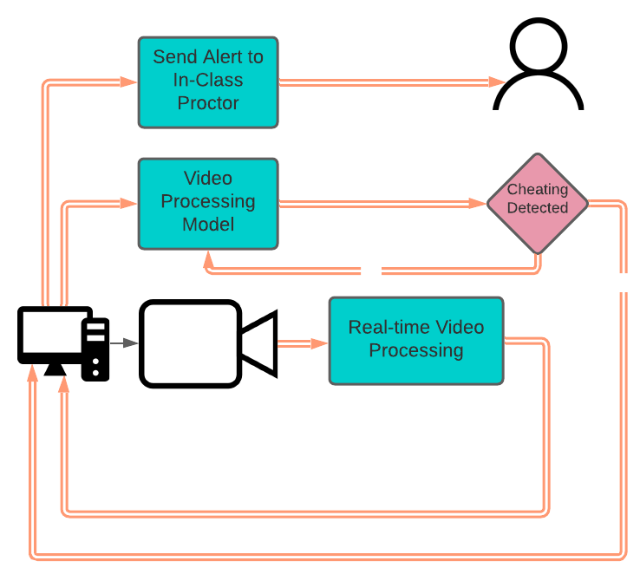

* 3.2 Software Architecture:

The software architecture consists of the main object detection model of the software. The model consists of different classifiers; Arm Movement Classifier, Head Movement Classifier, Note Passing Classifier, Body Direction Classifier, and Standing Person Classifier. Each frame from the video feed is passed to the model where the frame is classified according to the behavior of the student at that time.

Once the frame is classified a notification should be sent to the in-class proctor to alert him/her of the possible cheating incidents.

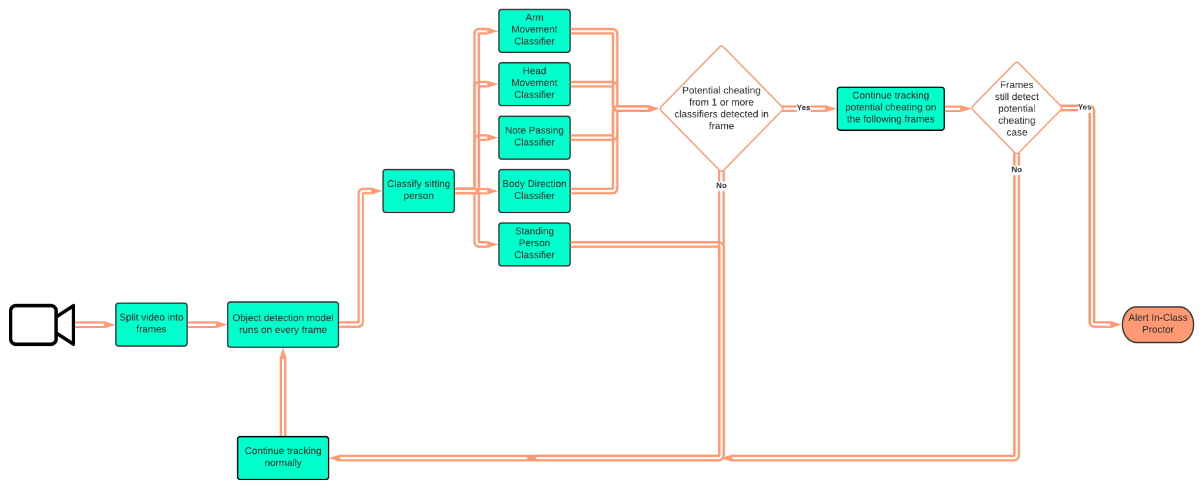

* 3.3 Communication Architecture:

As shown in the hardware architecture, the proctor gets notified on the monitor located in the classroom with the possible cheating incidents in the classroom. The proctor has the ability to report or dismiss the case.

* 4. Data Design

This section of the software design document will contain an overview of management of

of the data that will be stored in a database and also the management of the data that does not need to be stored in the database.

* 4.1 Database Management System Files

This subsection will mainly focus on the data that will be generated in our system and that will need a database to be stored. Our database will be MySQL. For the privileges part, permissions will be granted according to the two levels of privileges in RDBMS, which are account level or relation level. The account level, as well as the relation level privileges, will be assigned by the DBA, Database administrator/s which will have central authority for managing the database, i.e system account. The DBA will be responsible for granting or revoking privileges to individual accounts, users, or user groups and for performing certain actions. Below is the Entity-Relationship diagram of credentials in the database.

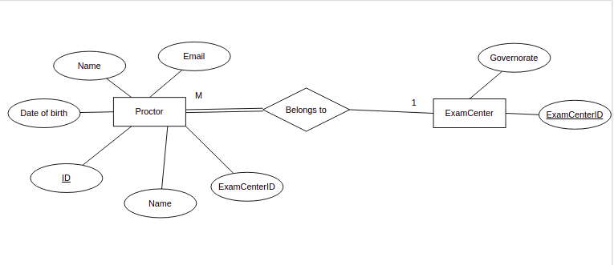

The database will mainly consist of two entities: Proctor and exam Center. The user will enter his/her name, date of birth, ID, Exam Center ID, and email then it will be stored in the database and linked with the corresponding ExamCenter table based on the exam center ID.

* 4.2 Non-Database Management System Files

In our system, we capture videos and feed live it to the developed software; yet, we do not provide the users with solutions of how to store recordings of the stream. So it’s actually up to them, either to store the whole recording or they only take a snapshot for the detected cheating incident. However, we suggest they store this kind of data locally, not in the cloud for security reasons.

* 5. Detailed Design:
* 5.1 Hardware Detailed Design :

The system mainly consists of the IP camera that is positioned in the center of the classroom to capture the classroom top view to have a good view of the classroom environment. The IP camera should have a minimum of 4MP resolution in order to capture the movement and object details in a classroom setting. The IP camera also should have a suitable range of a minimum of 8 meters in order to capture a classroom of average dimensions of 8*6 meters.

* 5.2 Software Detailed Design:

The software we develop consists of two main modules:

→Object detector: program that detects objects and humans after training a model using deep learning methods. In our case, we use a YOLO-based detector and this is because of the good balance between speed and accuracy that the model provides.

→ Classifier: after detecting the objects needed, mainly humans, we pass them to another model to classify the person's state: cheating, non-cheating, teacher. This model we developed and trained from scratch after investigating similar models in the literature.

* 5.3 Communication Detailed Design:

The proctor gets notified of any possible cheating incidents in the classroom which appears on the notification panel that appears on the software’s screen. The system communicates with an online secured database to store the login credentials of the system users.

* 6. Interfacing to External Systems:

→ Graphical User Interface: an interface that eases the usage of the software for teachers and staff recruited by the ministry of education to deal with the software.

→ Cables and ports: as mentioned above the output of the IP camera should be fed to the software modules. This is done by connecting the camera to the computer machine that contains the developed software using Cat5 Ethernet cable.

* 7. Usability Design Approach:

- Login Page:

The user (proctor) is asked to enter his/her credentials to access the software.

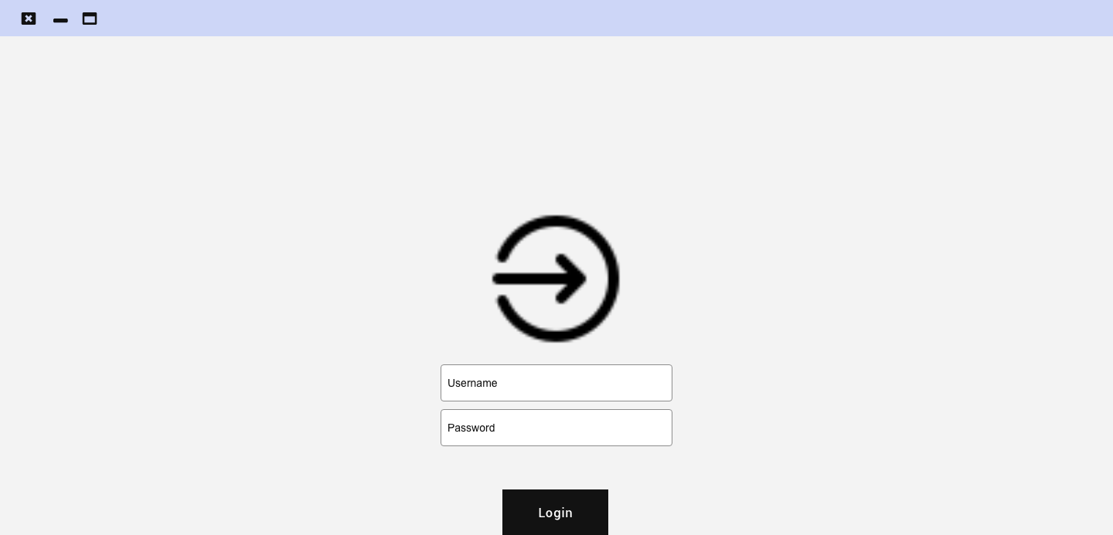

2- Home page:

The home page is where the user (proctor) can view a live stream of the classroom during the examination in addition to a notification panel where all possible cheating incidents are displayed on the panel to notify the proctor. The user selects any of the incidents to view more details, report, or dismiss the notification.

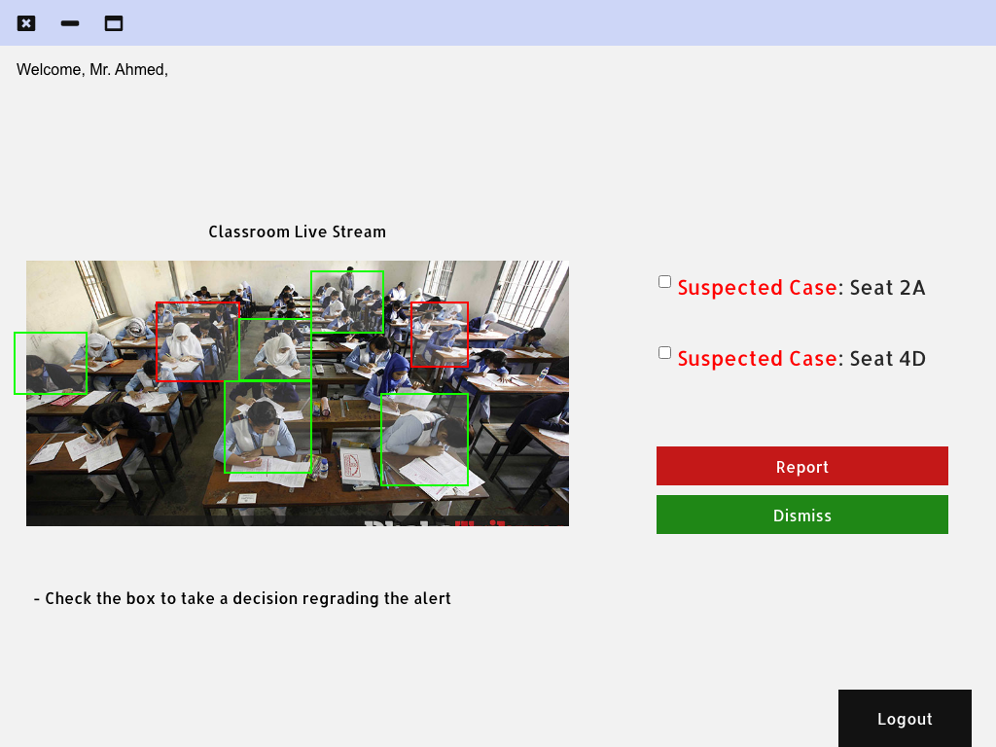

3- Case Details Page:

This page is viewed once the user selects any of the incidents on the notification panel on the home page. This page shows a snapshot of the incident with the seat number and an option to dismiss (after the student is checked by the proctor ) or report (to report the incident as a cheating incident)

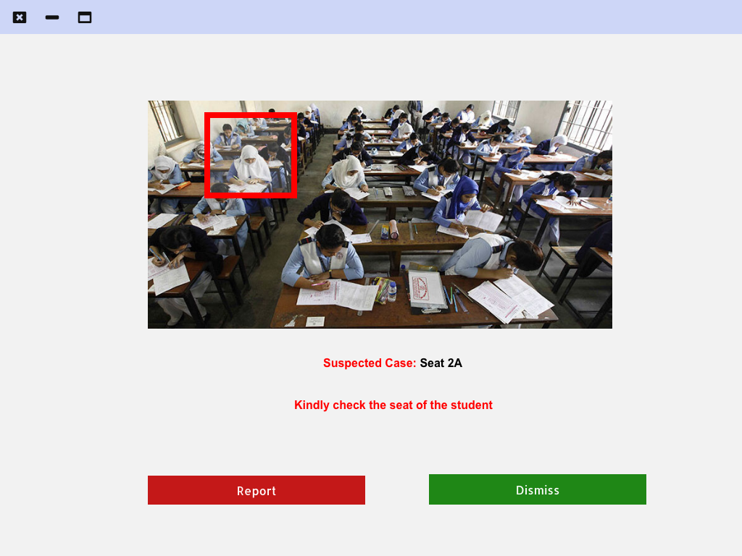

4- Exam Summary Page:

The page shows a summary of all dismissed (in green) and reported (in red) incidents by the proctor during the exam.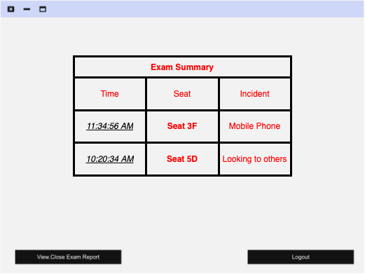

* 8. Glossary of Terms:
* RDBMS: Relational Database Management System
* YOLO: You Only Look Once Object Detection Tool
* FPS: Frames Per Second
* DBA: Database Administrator
* RCNN: Region-Based convolutional Neural Network
* CNN: Convolutional Neural Network